: Operator.c

\* Course : SOL1 WS2020

\* Author : Duru Emmanuel & Morjurul Islam zhimon

\* Date : 24.12.2020

Lab report:

First.c

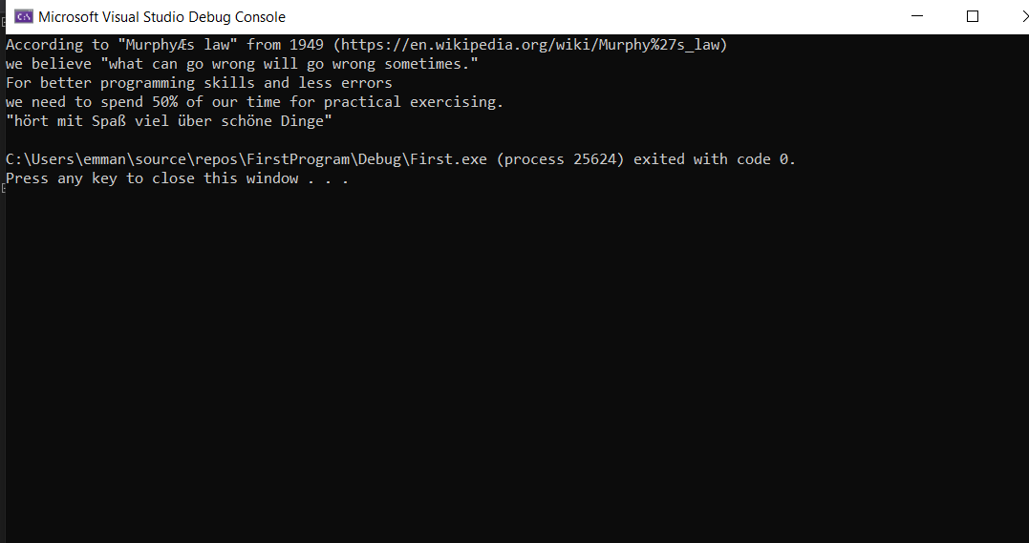

Operator.c

